**Project Paint Data**

# Step 1: Create Database Paint

create database Paint;

# Step 2: Use Database

use Paint;

# Step 3: Show Tables

show tables;

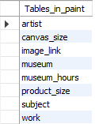

# Step 4: Joining Table

**Q.1) Retrieve the full name of artists along with the names of the museums where their works are displayed**.

select artist.full_name, museum.name

from artist

join work on artist.artist_id = work.artist_id

join museum on work.museum_id = museum.museum_id;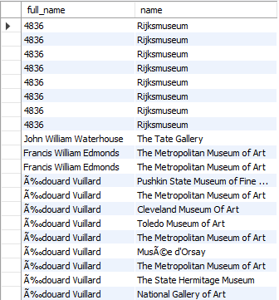

# Step 5: Group By and Count

**Q.2) How many works does each artist have in the database? Display the artist's full name along with the count of their works, ordered by the count in descending order.**

select artist.full_name, count(work.work_id) as work_count

from artist

left join work on artist.artist_id = work.artist_id

group by artist.artist_id, artist.full_name

order by work_count desc;

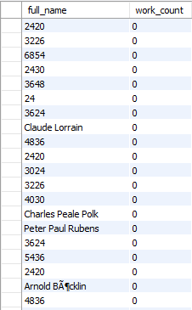

# Step 6: Order By and Limit

**Q.3) List the top 5 museums with the highest number of works displayed in the database, along with their respective counts.**

select museum.name, count(work.work_id) as work_count

from museum

left join work on museum.museum_id = work.museum_id

group by museum.museum_id, museum.name

order by work_count desc

limit 5

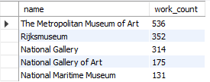

# Step 7: Join, Order By and Limit

**Q.4) Display the names and styles of the works along with the corresponding museum names, ordered by the museum name in ascending order. Limit the results to 10.**

select work.name, work.style, museum.name as museum_name

from work

join museum on work.museum_id = museum.museum_id

order by museum.name asc

limit 10;

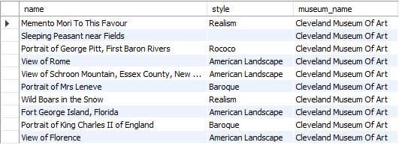

# Step 8: Join, Group By and Sum

**Q.5) Show the total sale price for each artist's works. Display the artist's full name along with the total sale price, ordered by the total sale price in descending order.**

select artist.full_name, count(work.work_id) as work_count

from artist

left join work on artist.artist_id = work.artist_id

group by artist.artist_id, artist.full_name

order by work_count desc;

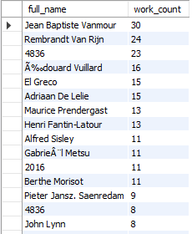

# Step 9: Join, Group By and Having

Q**.6) List artists who have more than 3 works in the database, along with the count of their works.**

select max(artist.full_name) AS full_name, count(work.work_id) as work_count

from artist

join work on artist.artist_id = work.artist_id

group by artist.artist_id

having work_count > 3;

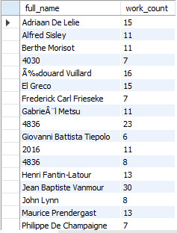

# Step 10: Join, Where and Order By

**Q.7) Retrieve the names of works and their corresponding artists' full names for works that have a sale price smaller than their regular price.**

Select work.name, artist.full_name

from work

join artist on work.artist_id = artist.artist_id

join product_size on work.work_id = product_size.work_id

where product_size.sale_price < product_size.regular_price;

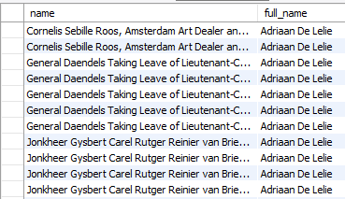

# Step 11: Join, Group and Average

**Q.8) Calculate the average height and width of the artworks in the database. Display the average height and width.**

select avg(canvas_size.height) as avg_height,

avg(canvas_size.width) as avg_width

from canvas_size;



# Step 12: Join, Group By and Max

**Q.9) Find the maximum sale price among all the works in each museum. Display the museum name along with the maximum sale price.**

select m.name, ps.max_sale_price

from museum m

join (

select work.museum_id, max(product_size.sale_price) as max_sale_price

from work

join product_size on work.work_id = product_size.work_id

group by work.museum_id

) ps on m.museum_id = ps.museum_id;

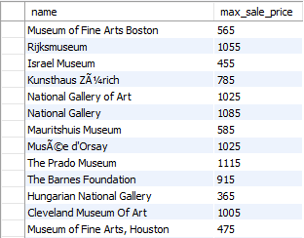

# Step 13: Join, Group By and Concatenate

**Q.10) Concatenate the first name and last name of artists along with their nationality, separated by a comma. Display the concatenated string along with the count of works by each artist, ordered by the count in descending order.**

SELECT CONCAT(artist.first_name, ' ', artist.last_name, ', ', artist.nationality) AS artist_info, COUNT(work.work_id) AS work_count

FROM artist

JOIN work ON artist.artist_id = work.artist_id

GROUP BY artist.artist_id, artist.first_name, artist.last_name, artist.nationality

ORDER BY work_count DESC;

